MATHEMATICS APPLICATIONS

MAWA Semester 1 (Unit 3) Examination 2017

Calculator-Assumed

Marking Key

© MAWA, 2017
Licence Agreement
This examination is Copyright but may be freely used within the school that purchases this licence.
- The items that are contained in this examination are to be used solely in the school for which they are purchased.
- They are not to be shared in any manner with a school which has not purchased their own licence.
- The items and the solutions/marking keys are to be kept confidentially and not copied or made available to anyone who is not a teacher at the school. Teachers may give feedback to students in the form of showing them how the work is marked but students are not to retain a copy of the paper or marking guide until the agreed release date stipulated in the purchasing agreement/licence.

The release date for this exam and marking scheme is
- the end of week 8 of term 2, 2017

Section Two: Calculator-assumed (100 Marks)

Question 7 (a)(b)(c)
Solution

Day | 1 | 2 | 3 | 4 | 5
Number of metres | 75 | 125 | 175 | 225 | 275

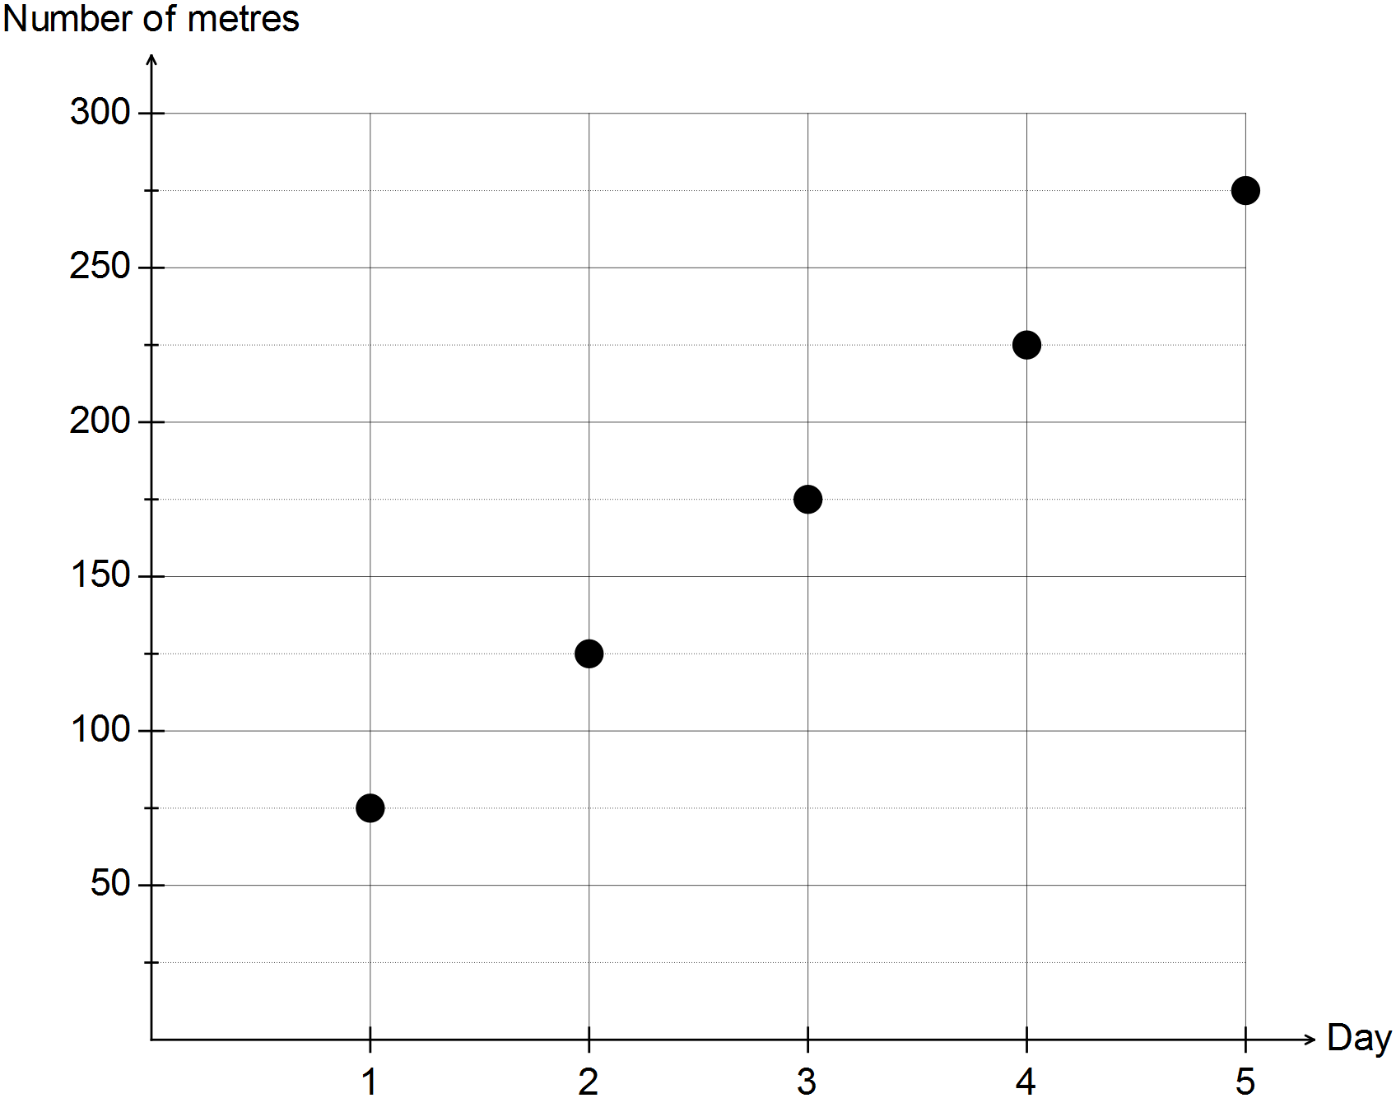
T_{n} = 50n + 25

Marking key/mathematical behaviours | Marks
- enters starting value plus one other to table  - completes table  - labels axes  - scales axes  - plots points from table  - uses format for n^{th} rule with correct difference  - uses fixed term in rule | 1  1  1  1  1  1  1

Question 8 (a)
Solution

 |  | Lesson times
Age group | Age range | 4 pm | 5 pm | 7 pm | 8 pm | Total
Primary | 5 to 12 | 10 | 7 | 6 | 2 | 25
Secondary | 12-18 | 5 | 7 | 10 | 3 | 25
Tertiary | 19-25 | 4 | 5 | 7 | 9 | 25
Older adult | Over 25 | 2 | 3 | 4 | 16 | 25
 | Total | 21 | 22 | 27 | 30 | 100

Marking key/mathematical behaviours | Marks
- determines 2 missing values  - determines another 2 missing values | 1  1

Question 8 (b)
Solution

27%
Marking key/mathematical behaviours | Marks
- determines percentage | 1

Question 8 (c)
Solution

16%
Marking key/mathematical behaviours | Marks
- identifies percentage | 1

Question 8 (d)
Solution

There are 10% in secondary and 30% in tertiary
The % in tertiary is three times that of secondary
Marking key/mathematical behaviours | Marks
- determines the percentages for each group  - compares the two groups | 1  1

Question 8 (e)
Solution

Generally – the older the student the later they prefer to have a lesson
For primary the later the lesson the less it is preferred.
For tertiary and older adult, the later the lesson the more it is preferred
For secondary the association is not as clear because there is not a consistent pattern across the lesson times

Marking key/mathematical behaviours | Marks
- states a general conclusion  - summarises the association for tertiary and older adults  - summarises the association for secondary  - summarises the association for primary | 1  1  1  1

Question 9 (a)
Solution

BCKG 152 km
BCG 109 km
BCLMG 173 km
BCLMWG 213 km
BEWG 106 km
BEWMG 186 km
The shortest distance is 106 km and the path is BEWG

Marking key/mathematical behaviours | Marks
- determines shortest path  - determines distance of shortest path  - provides evidence of the distance of at least 2 other paths  - provides evidence of the distance of a fourth path  - provides evidence of the distance of a fifth path | 1  1  1  1  1

Question 9 (b)
Solution

It is a path because all edges and vertices in the route are different
Marking key/mathematical behaviours | Marks
- identifies edges need to be different  - identifies vertices need to be different | 1  1

Question 9 (c)
Solution

GMLCB is the shortest route and it is 173 km. It is 67 km longer.
Marking key/mathematical behaviours | Marks
- identifies shortest path through L  - compares new path to the initial path | 1  1

Question 9 (d)
Solution

Yes – there are distances marked on the edges
Marking key/mathematical behaviours | Marks
- identifies features of a weighted graph in relation to the one provided | 1

Question 10 (a)(b)(c)
Solution

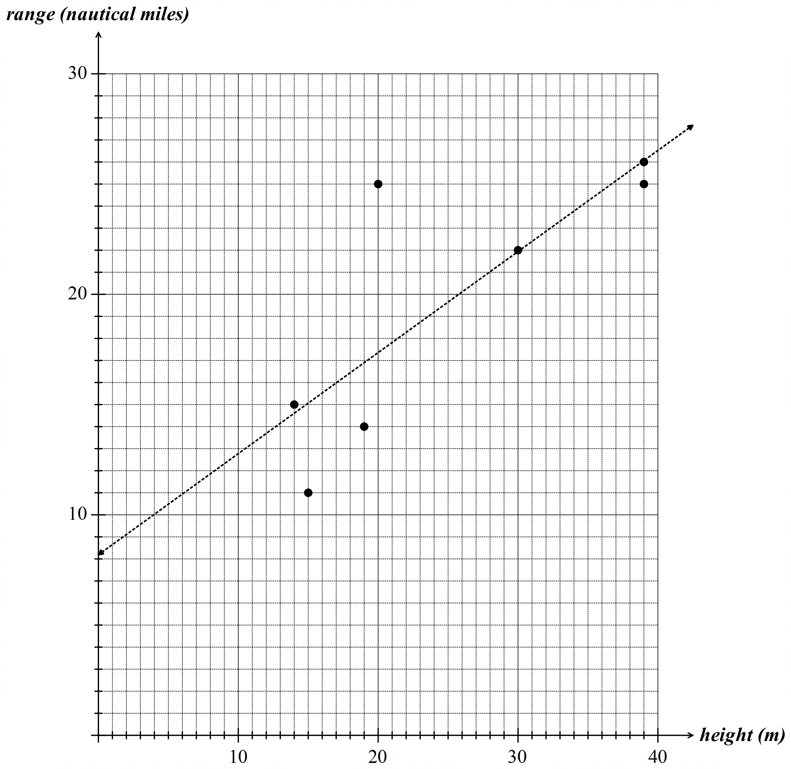

(b) Range = height x 0.4583 +8.1913 (c) see graph
Marking key/mathematical behaviours | Marks
- scales and labels response variable on vertical axis  - scales and labels explanatory variable on horizontal axis  - identifies scatter plot as a series of data points  - plots 3 points  - plots 2 more points 5 points  - plots 2 more points 7 points  - uses correct variables and linear format for equation  - uses correct intercept and gradient in equation  - identifies vertical intercept for least squares line  - draws line with gradient as per equation | 1  1  1  1  1  1  1  1  1  1

Question 10 (d)
Solution

Lighthouse F
It is furtherest away from the line
Marking key/mathematical behaviours | Marks
- identifies most extreme value  - justifies the selection | 1  1

Question 10 (e)
Solution

0.6343
Marking key/mathematical behaviours | Marks
- identifies coefficient of determination | 1

Question 10 (f)
Solution

20 (19.6) nautical miles
Marking key/mathematical behaviours | Marks
- substitutes into equation for least squares line  - determines range in nautical miles | 1  1

Question 10 (g)
Solution

(i) interpolation OR high correlation coefficient at about 0.8
(ii) not many data points have been used to determine the equation OR line influenced by what appears to be an outlier
Marking key/mathematical behaviours | Marks
- identifies initial edge and finishing point  - identifies edges for quickest route from F to B | 1  1

Question 11 (a)
Solution

Recording | 1 | 2 | 3 | 4 | 5 | 6 | 7
Water level (L) | 2000 | 1850 | 2000 | 1850 | 2000 | 1850 | 2000

Marking key/mathematical behaviours | Marks
- enters first two values into table  - completes the table | 1  1

Question 11 (b)
Solution

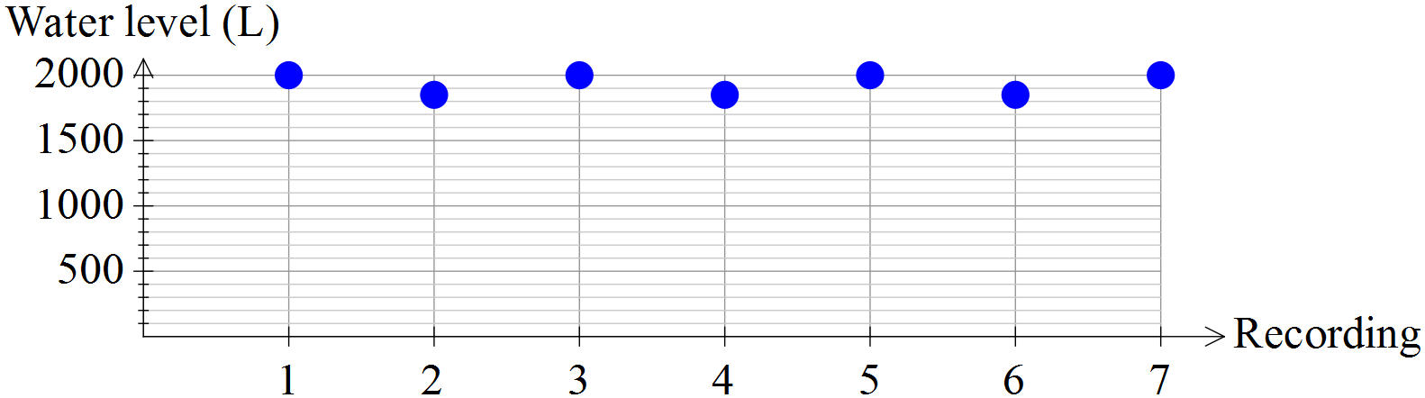

Marking key/mathematical behaviours | Marks
- scales and labels vertical axis  - plots 5 points from table  - plots two more points from table | 1  1  1

Question 11 (c)
Solution

Water level reaches a steady state
Marking key/mathematical behaviours | Marks
- identifies long-term trend | 1

Question 11 (d)
Solution

The loss is equal to what is gained.
Marking key/mathematical behaviours | Marks
- describes conditions for reaching steady state | 1
Question 11 (e)
Solution

T₁ = 2000, T_{n + 1} = 0.925T_{n} + 150
Marking key/mathematical behaviours | Marks
- defines first term  - uses formula for first order linear recurrence relation with constant  - identifies rate | 1  1  1

Question 11 (f)
Solution

W₂ = 1670, W₃ = 1637
Marking key/mathematical behaviours | Marks
- determines second term  - determines third term | 1  1

Question 12 (a)
Solution

Intersection of the streets /where the different streets meet
Marking key/mathematical behaviours | Marks
- identifies vertices as where edges meet | 1

Question 12 (b)
Solution

M and V
Marking key/mathematical behaviours | Marks
- identifies all odd vertices | 1

Question 12 (c)
Solution

VTMVQSBQLSTLM
Marking key/mathematical behaviours | Marks
- starts and ends with an odd vertex  - lists edges so that all are covered  - lists edges with no repeats | 1  1  1

Question 12 (d)
Solution

Streets can be represented by edges, meeting of streets can be represented by the nodes
Marking key/mathematical behaviours | Marks
- explains use of network | 1

Question 12 (e)
Solution

V + f – e = 2 7 + 7 – 12 = 2
Marking key/mathematical behaviours | Marks
- substitutes correctly into Euler’s rule  - determines values according to Euler’s rule | 1  1

Question 12 (f)
Solution

Is Eulerian as it has a closed trail. Starts and ends at the same vertex. Can go over every edge once only.
Marking key/mathematical behaviours | Marks
- explains closed nature of the network  - links definition to starting and ending at the same vertex | 1  1

Question 13 (a)
Solution

500. At n = 1, P=500
Marking key/mathematical behaviours | Marks
- determines first term  - justifies first term | 1  1

Question 13 (b)
Solution

500 x 1.2⁹ = 2580
Marking key/mathematical behaviours | Marks
- substitutes into rule  - evaluates subject | 1  1

Question 13 (c)
Solution

Growing at 20% per week
Marking key/mathematical behaviours | Marks
- identifies rate of growth | 1

Question 13 (d)
Solution

B is faster, the dots are rising more quickly
Marking key/mathematical behaviours | Marks
- identifies faster rate  - justifies choice | 1  1

Question 13 (e)
Solution

Geometric. The rate of change is proportional rather than a fixed value
Marking key/mathematical behaviours | Marks
- identifies growth is geometric  - justifies selection | 1  1

Question 13 (f)
Solution

Week 4
Marking key/mathematical behaviours | Marks
- interprets graph of sequences | 1

Question 13 (g)
Solution

Rate = 420 ÷ 300 = 1.4
P = 300 (1.4) ^{n - 1}
Marking key/mathematical behaviours | Marks
- determines rate of growth  - identifies equation with format and starting value  - identifies exponent | 1  1  1

Question 14 (a)
Solution

ALTREHBPSMA
Marking key/mathematical behaviours | Marks
- starts and ends at A  - route considers all vertices  - no vertices repeated | 1  1  1

Question 14 (b)
Solution

6
LM,PA,HS,ET,BT,PT
Marking key/mathematical behaviours | Marks
- determines number of unused paths  - names number of unused paths | 11

Question 14 (c)
Solution

Yes – it is closed
No edges are repeated and every vertex is visited once only
Marking key/mathematical behaviours | Marks
- identifies route as a cycle  - identifies related description of edges and vertices | 1  1

Question 14 (d)
Solution

Not semi-eulerian
Not all edges are crossed
Marking key/mathematical behaviours | Marks
- concludes not semi-eulerian  - justifies conclusion | 1  1

Question 14 (e)
Solution

TRUE: Connected as all vertices are linked by at least one edge to another vertex
TRUE: Simple as no loops or multiple edges
FALSE: Walk not BPHS because there is no edge from P to H
Marking key/mathematical behaviours | Marks
- identifies graph is connected and explains  - identifies graph is simple and explains  - identifies not a walk and explains | 1  1  1

Question 15
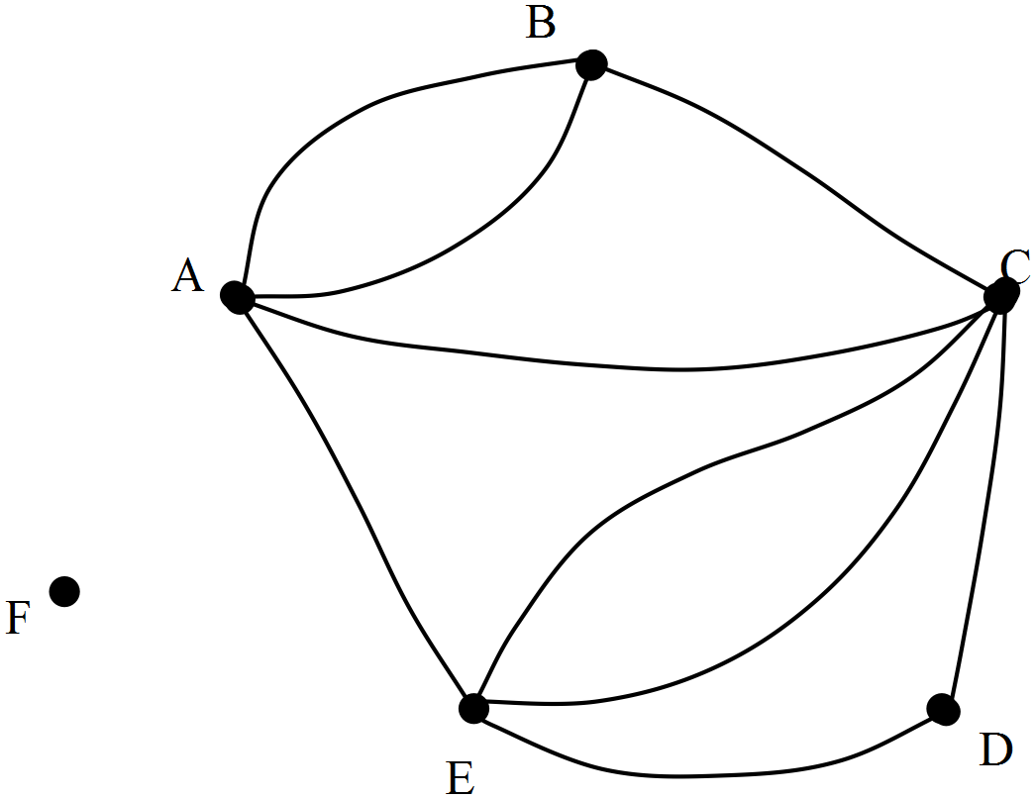Solution

Marking key/mathematical behaviours | Marks
- identifies all 6 nodes  - draws two paths between A and B and between C and E  - draws one path to represent “1” in the matrix  - has not extra edges  - leaves F unconnected | 1  1  1  1  1

Question 16 (a)
Solution

When TF = 8, the residual is 10. The observed value for TC is 10 more than that predicted by the least squares line.
Marking key/mathematical behaviours | Marks
- identifies the size of the residual for a particular TF value  - compares TF predicted with the observed value | 1  1

Question 16 (b)
Solution

The value of the observed TC is less than that predicted by the model
Marking key/mathematical behaviours | Marks
- explains the negative residual | 1

Question 16 (c)
Solution

A residual plot is used to support the identification of the linear trend for bivariate data.
If the residuals are scattered “evenly” around the horizontal axis then this lend support to the idea that the relationship between the two variables is linear.
Marking key/mathematical behaviours | Marks
- describes why residual plot is used  - describes how residual plot is used | 1  1

